# RAM Consolidated Workbench

### Creating a New Project Network

Join projects in a project network using 'oadm pod-network join-projects' command

$ oadm pod-network join-projects --to=<project name 1> <project name 2> <project name 3> ...

[root@master01-devtest-vxbyr ~]# oadm pod-network join-projects --to=ram-dev4 ram-intdev5 ram-dev1 ram-dev12 ram-test2 ram-dev7 ram-uat1 ram-test6 ram-intdev1 ram-intdev3 ...

Append all projects to join in a single command.

### Adding to an Existing Project Network

Add projects to an existing project network using 'oc edit netnamespace' command

$ oc edit netnamespace

Search for the project using "/" in the yaml file then replace the project netid with an existing project netid.

Save and close the yaml file using ":wq!".

Here are the screenshots for finding the netid of ram-dev1:

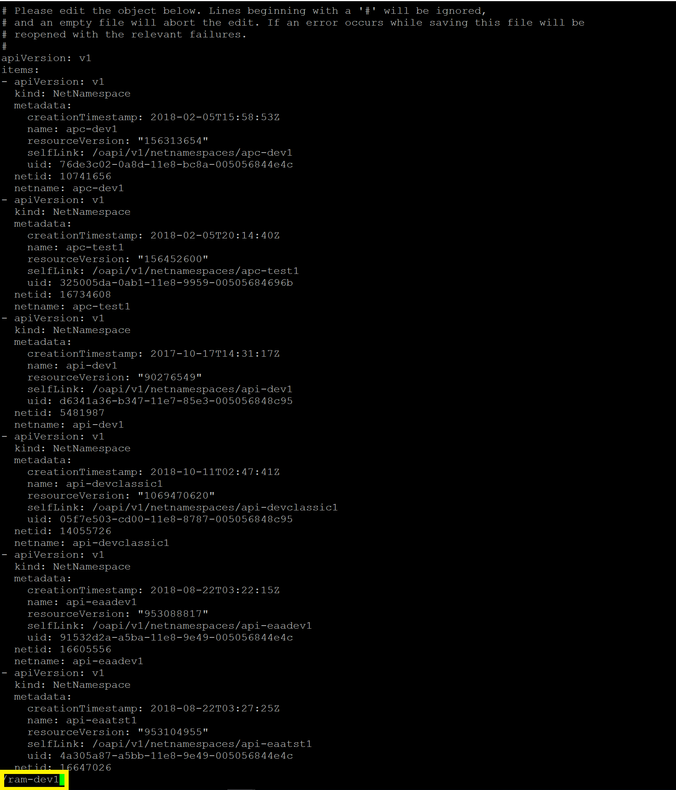

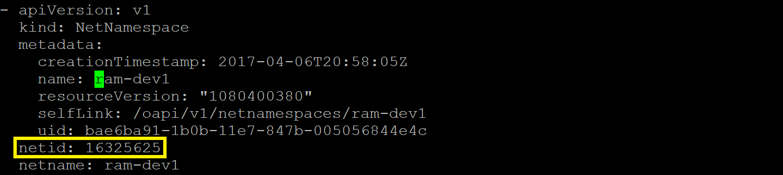

### Validating Project Networks

Get project netids using "oc get netnamespaces" command

[svc-vxby-ose@master01-devtest-vxbyr ~]$ oc get netnamespaces

NAME NETID

apc-dev1 10741656

apc-test1 16734608

api-dev1 5481987

api-devclassic1 14055726

api-eaadev1 16605556

api-eaatst1 16647026

api-tst1 5939420

aqua-security 1871273

bridges-dev1 1868314

bridges-test1 5840438

bridges-test2 6646226

...

Get projects in a particular project network with a unique netid using "grep -v" command

$ oc get netnamespaces | grep <netid>

[svc-vxby-ose@master01-devtest-vxbyr ~]$ oc get netnamespaces | grep 16325625

hws-dev1 16325625

hws-dev2 16325625

hws-dev3 16325625

hws-test1 16325625

hws-test2 16325625

hws-test3 16325625

leo-dev1 16325625

leo-dev2 16325625

leo-test1 16325625

leo-workbench1 16325625

...

Get projects NOT in a particular project network using "grep -v" command

$ oc get netnamespaces | grep -v <netid>

[svc-vxby-ose@master01-devtest-vxbyr ~]$ oc get netnamespaces | grep -v 16325625

NAME NETID

apc-dev1 10741656

apc-test1 16734608

api-dev1 5481987

api-devclassic1 14055726

api-eaadev1 16605556

api-eaatst1 16647026

api-tst1 5939420

aqua-security 1871273

bridges-dev1 1868314

bridges-test1 5840438

...